**Problem**

Take in distance, airspeed, windspeed, fuel burn rate, fuel price, number of people, seconds of animation to calculate the cost per person, and display an animation of the flight according to how long the user wants it to be.

**Flowchart**

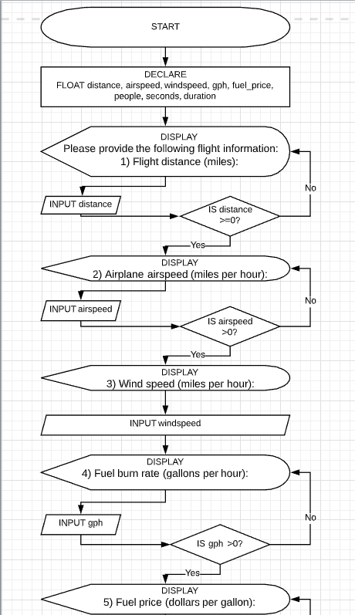

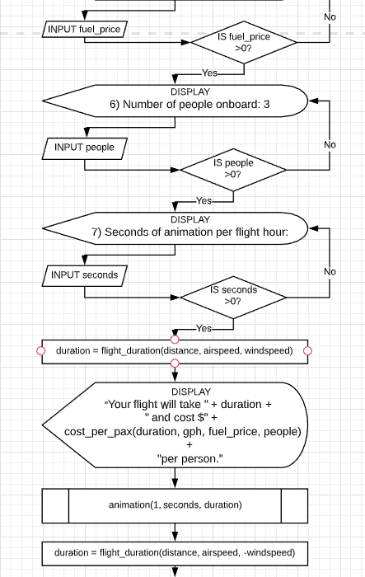

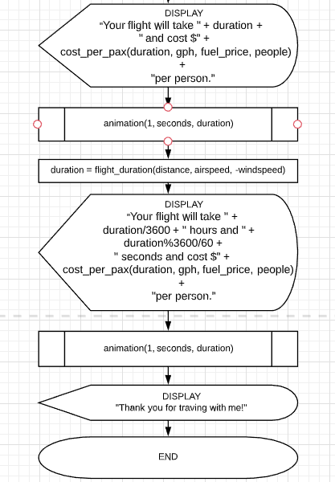

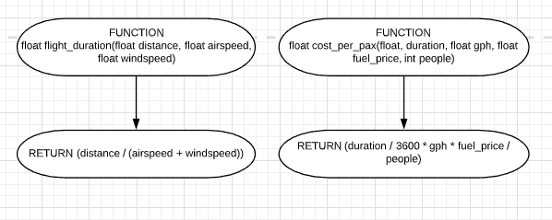

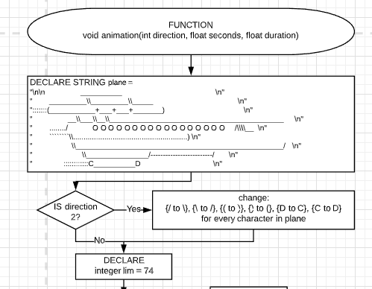

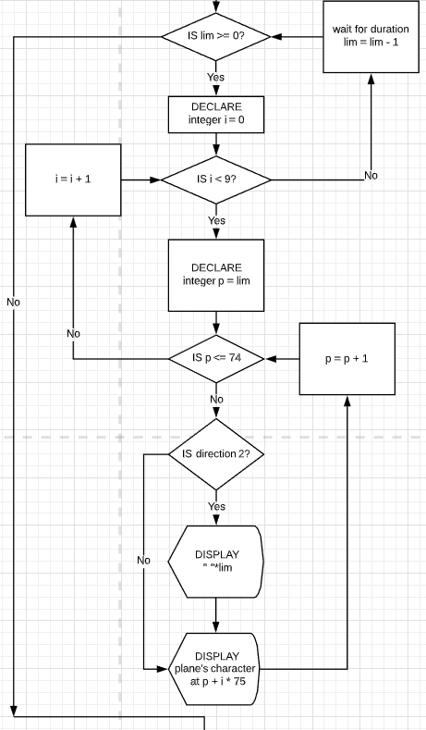



**Test Cases**

|  |  |  |
| --- | --- | --- |
| Test case setting | User input | Expected result |
| DISPLAY Please provide the following flight information:  1) Flight distance (miles): | 10 | DISPLAY 2) Airplane airspeed (miles per hour): |
| DISPLAY Please provide the following flight information:  1) Flight distance (miles): | 0 | DISPLAY Please provide the following flight information:  1) Flight distance (miles): |
| DISPLAY Please provide the following flight information:  1) Flight distance (miles): | -1 | DISPLAY Please provide the following flight information:  1) Flight distance (miles): |
| DISPLAY 2) Airplane airspeed (miles per hour): | 10 | DISPLAY 3) Wind speed (miles per hour): |
| DISPLAY 2) Airplane airspeed (miles per hour): | 0 | DISPLAY 2) Airplane airspeed (miles per hour): |
| DISPLAY 2) Airplane airspeed (miles per hour): | -10 | DISPLAY 2) Airplane airspeed (miles per hour): |
| DISPLAY 4) Fuel burn rate (gallons per hour): | 10 | DISPLAY 5) Fuel price (dollars per gallon): |
| DISPLAY 4) Fuel burn rate (gallons per hour): | 0 | DISPLAY 4) Fuel burn rate (gallons per hour): |
| DISPLAY 4) Fuel burn rate (gallons per hour): | -10 | DISPLAY 4) Fuel burn rate (gallons per hour): |
| DISPLAY 5) Fuel price (dollars per gallon): | 10 | DISPLAY 6) Number of people onboard: 3 |
| DISPLAY 5) Fuel price (dollars per gallon): | 0 | DISPLAY 5) Fuel price (dollars per gallon): |
| DISPLAY 5) Fuel price (dollars per gallon): | -10 | DISPLAY 5) Fuel price (dollars per gallon): |
| DISPLAY 6) Number of people onboard: 3 | 10 | DISPLAY 7) Seconds of animation per flight hour: |
| DISPLAY 6) Number of people onboard: 3 | 0 | DISPLAY 6) Number of people onboard: 3 |
| DISPLAY 6) Number of people onboard: 3 | -10 | DISPLAY 6) Number of people onboard: 3 |